User Manual Documentation (Administrator)

1. **LOGIN**: Admin must login by navigating to login page and enter credentials and select the employee check box.

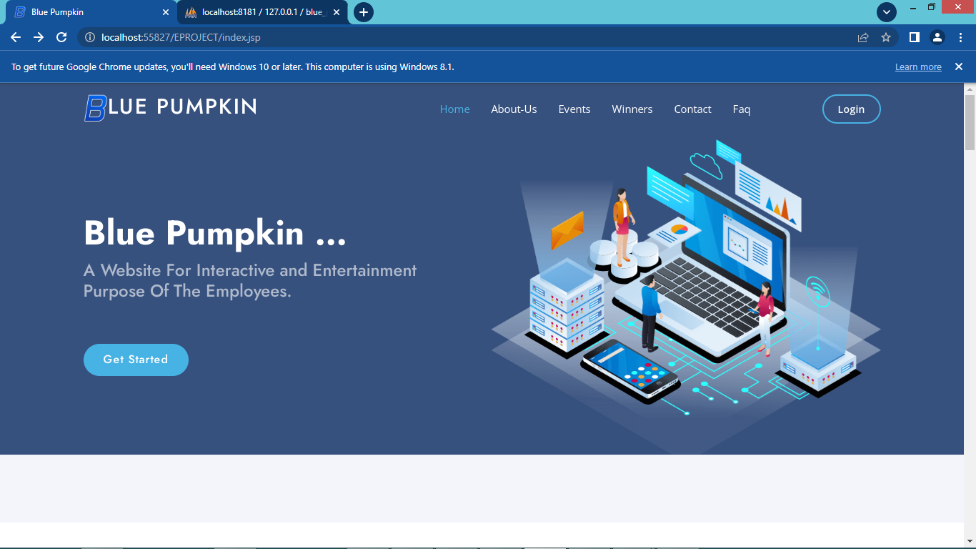

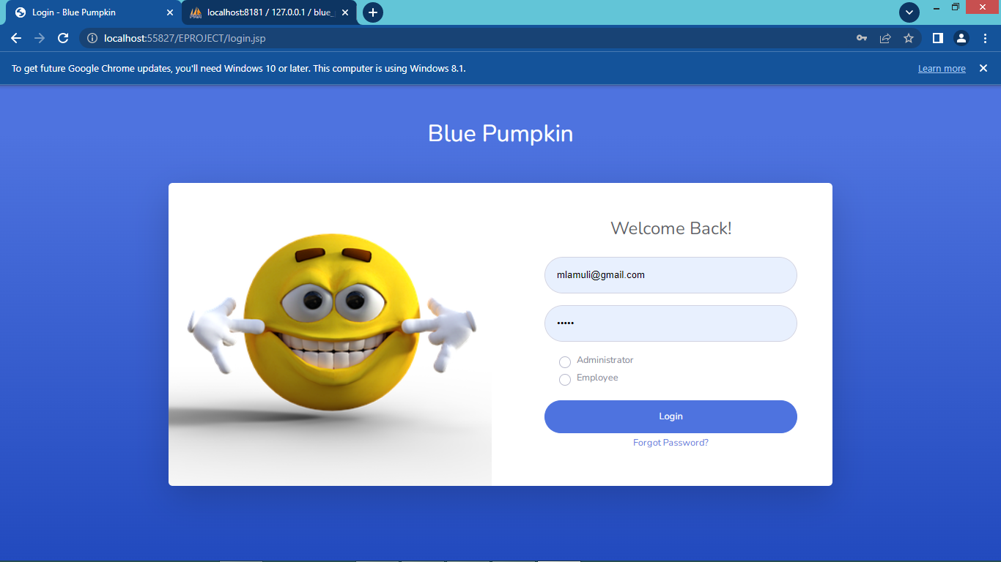

1.

2. **CREATE EVENT:** Fill the form and click Add Event button.

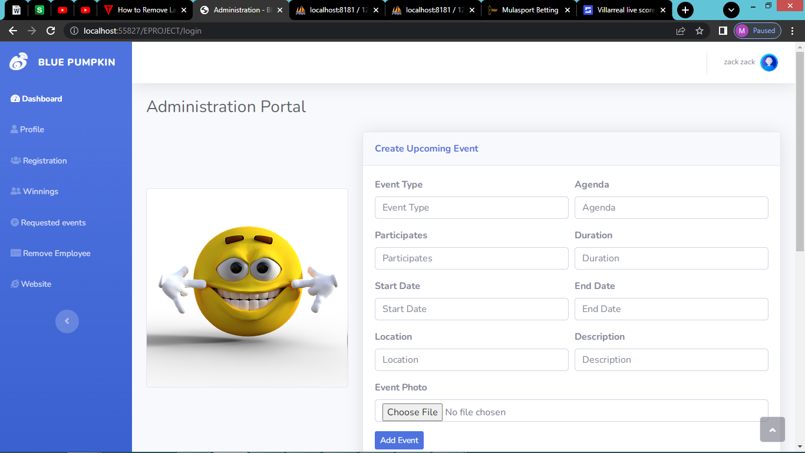

**View Posted Events:** scroll down the dashboard page**.**

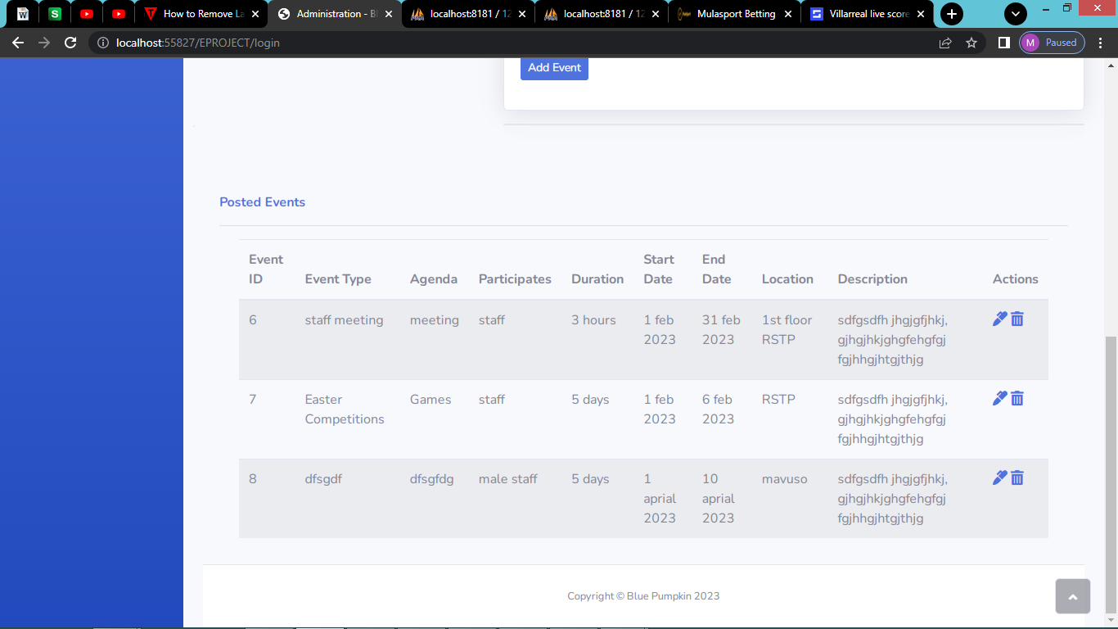

**2.**

**Edit Posted Event:** click the actions edit button aside of the event to edit.

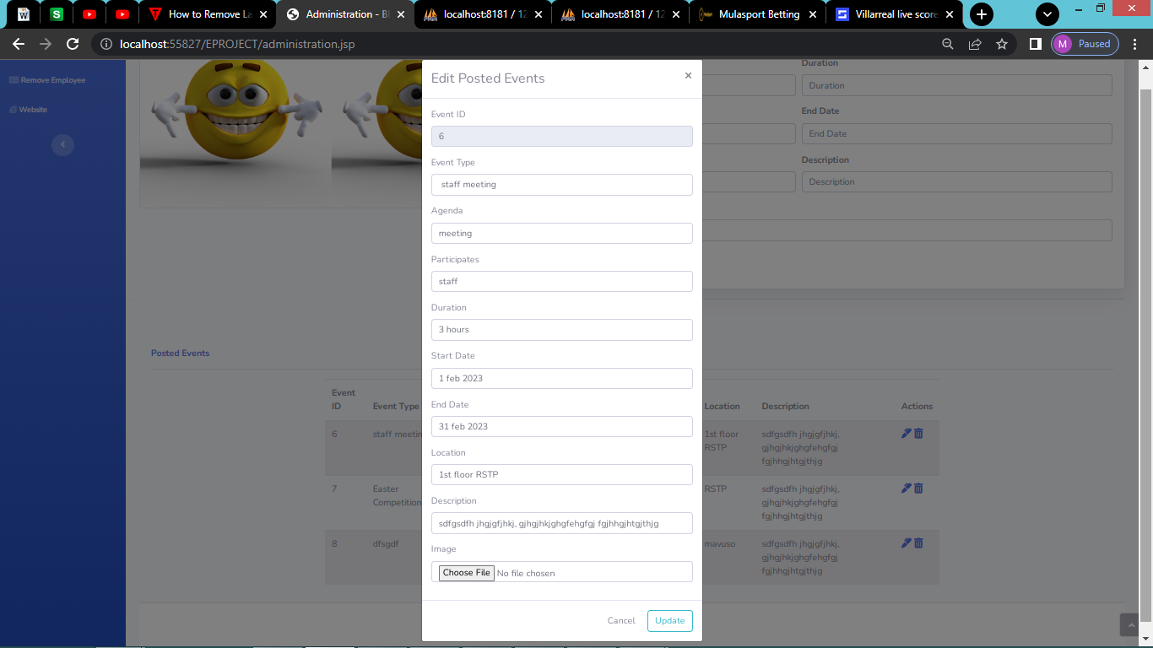

**Profile:** Fill the formand edit profile.

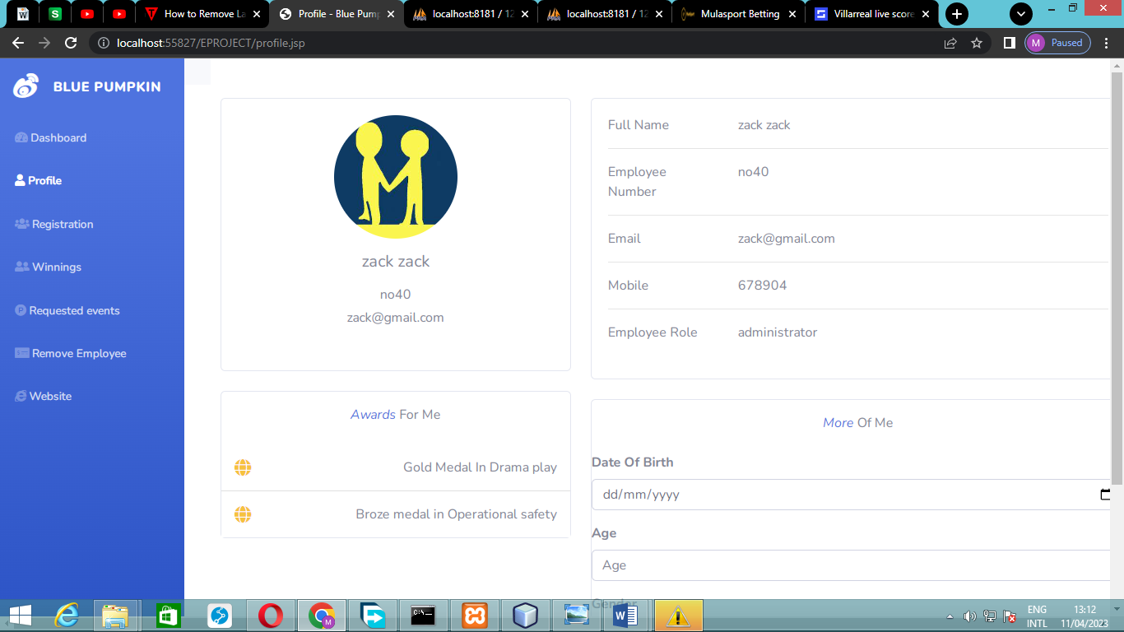

3.

3. **REGISTER EMPLOYEE AND ADMIN:** fill the form and click Register Account button.

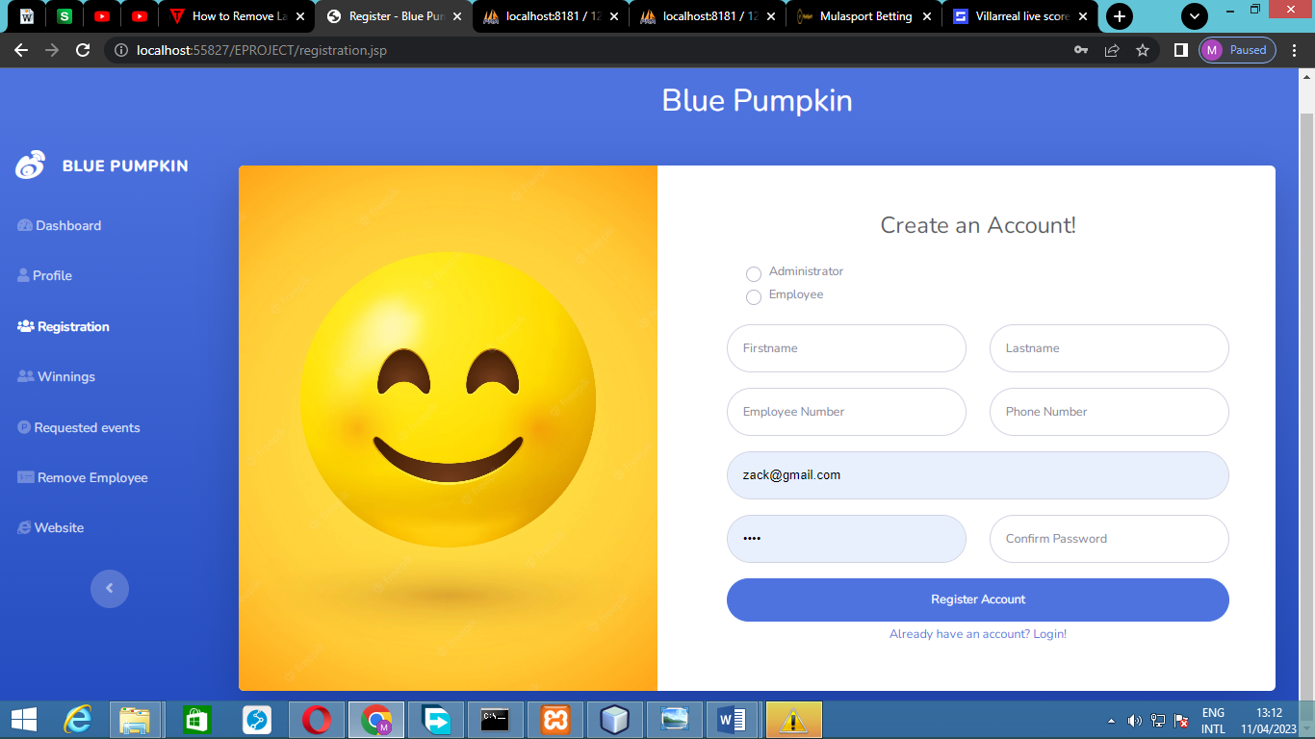

**4. POST WINNERS:** Fill the form and post winners of tournaments.

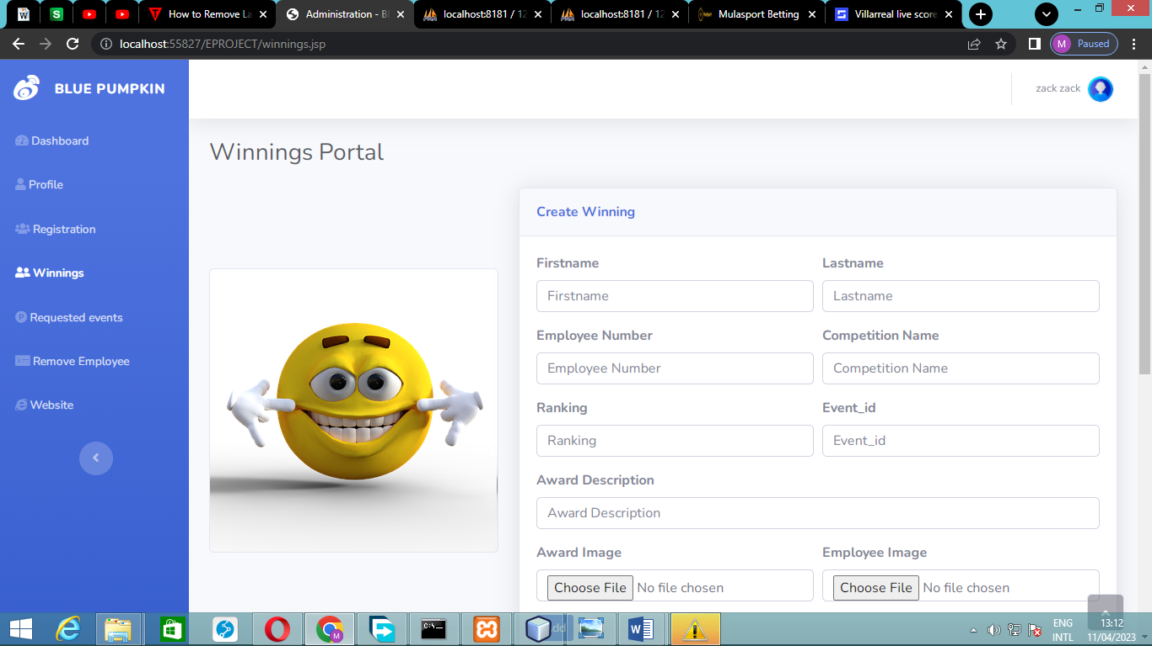

4.

**View Posted winners:**  Scroll down the create winners page.

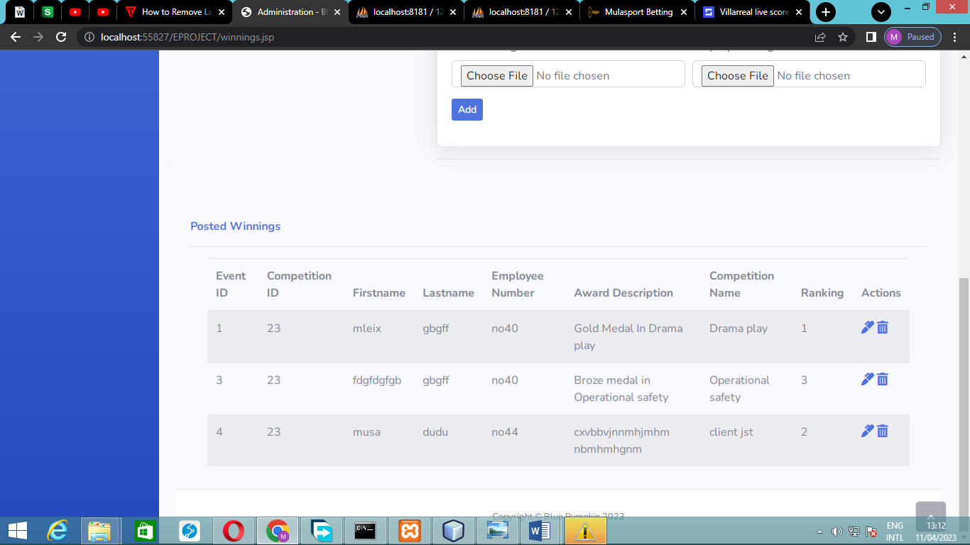

**Edit posted winners:** click the actions edit button aside of the posted winners to edit.

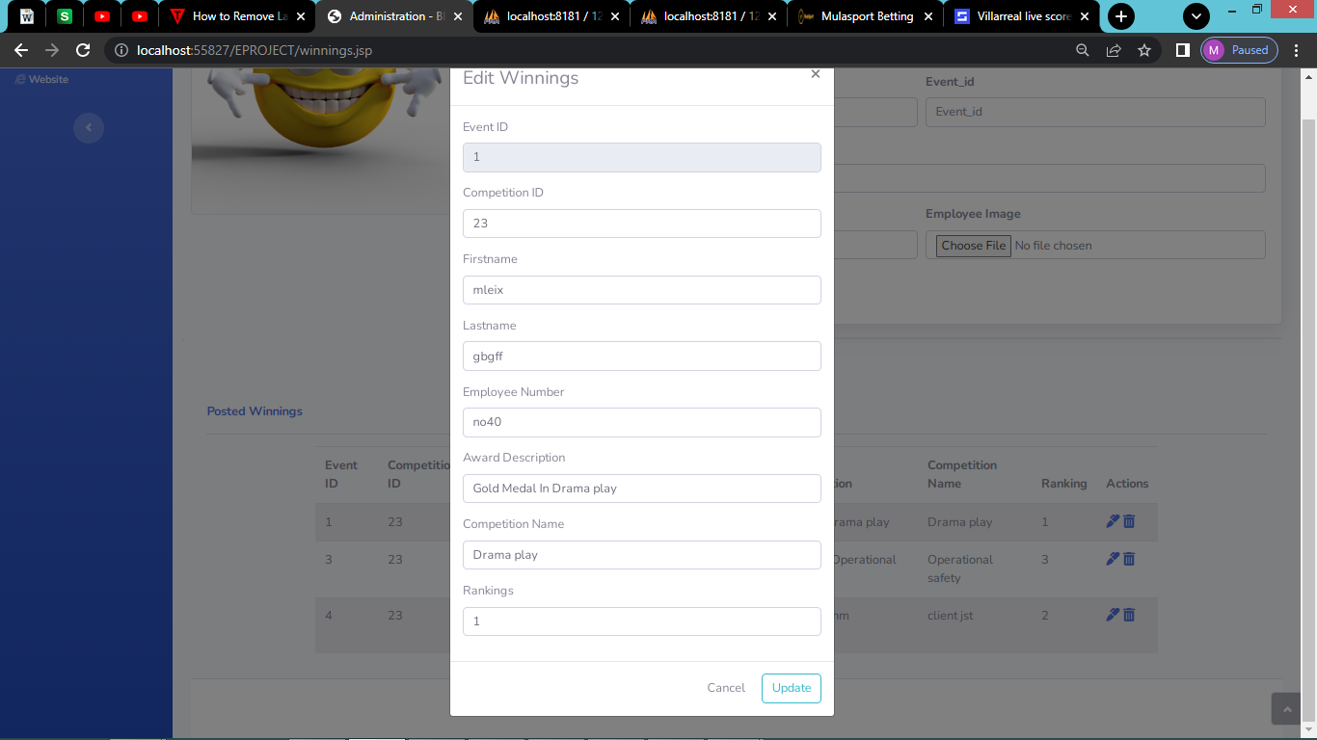

5.

**5. REQUESTED EVENTS:** Navigate to requested event on the sidebar

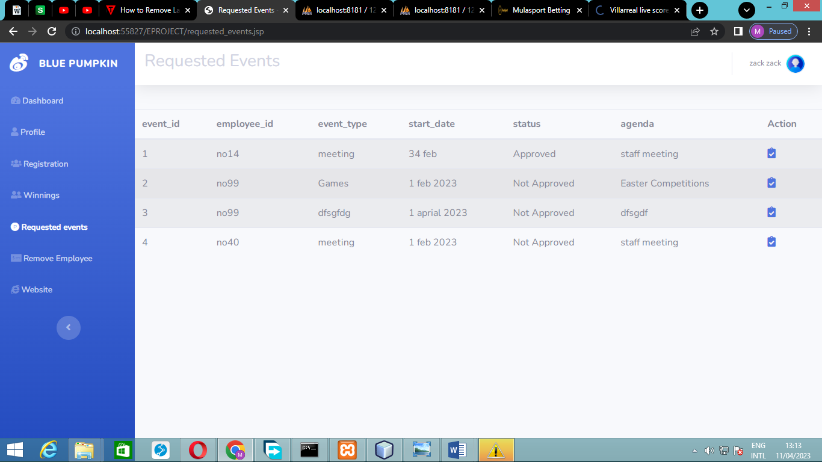

**Approve Requested Event:** click the actions button aside of the Requested Event to approve.

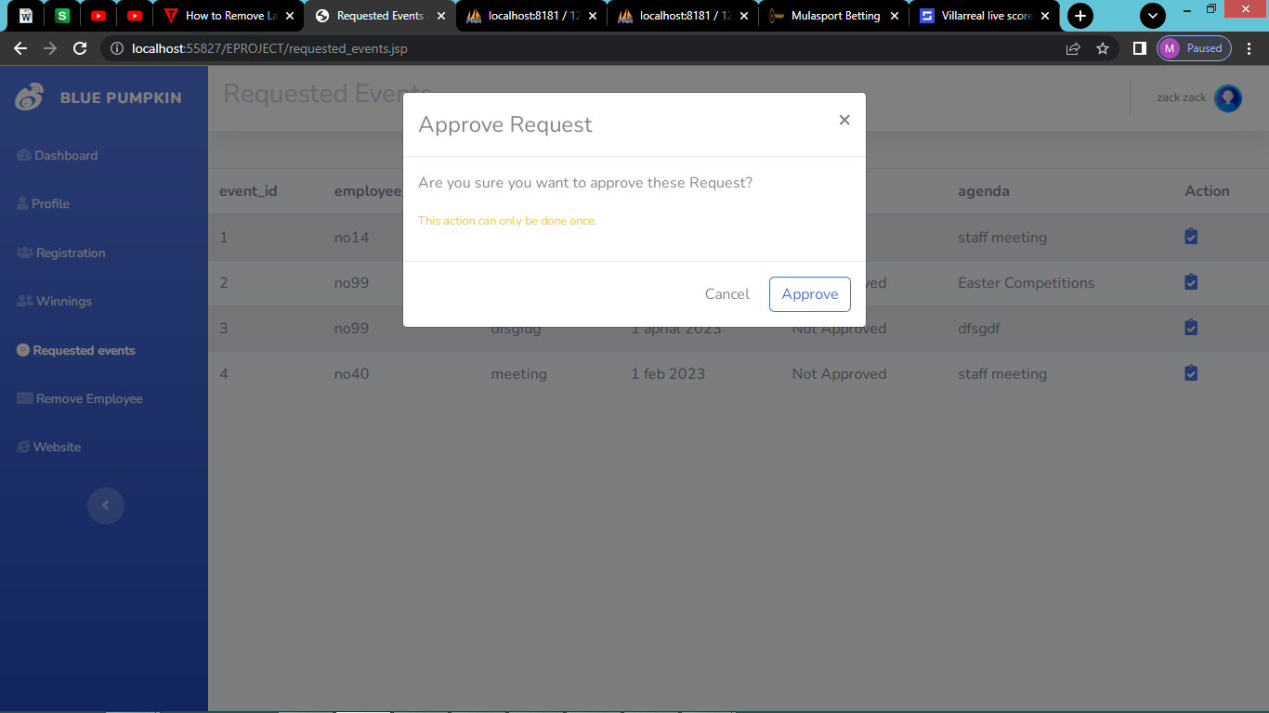

6.

**6. VIEW EMPLOYEE:** Navigate to Remove Employee on the sidebar

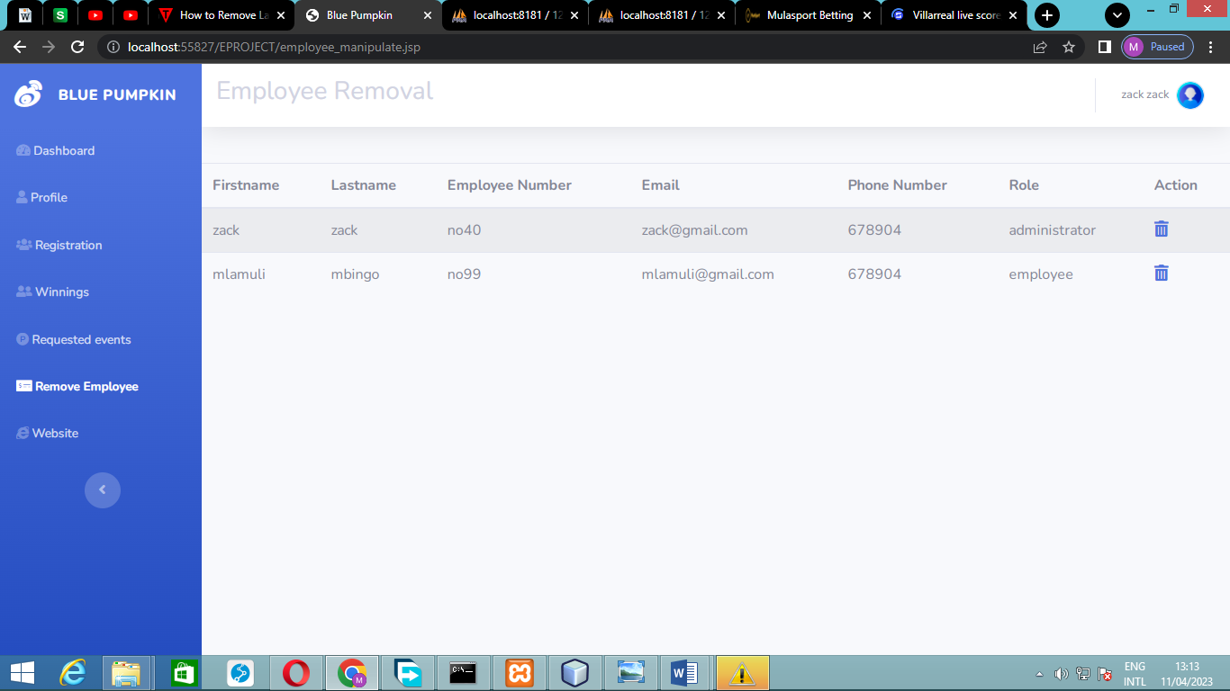

**Remove Employee:** click the actions button aside of the employee to approve.

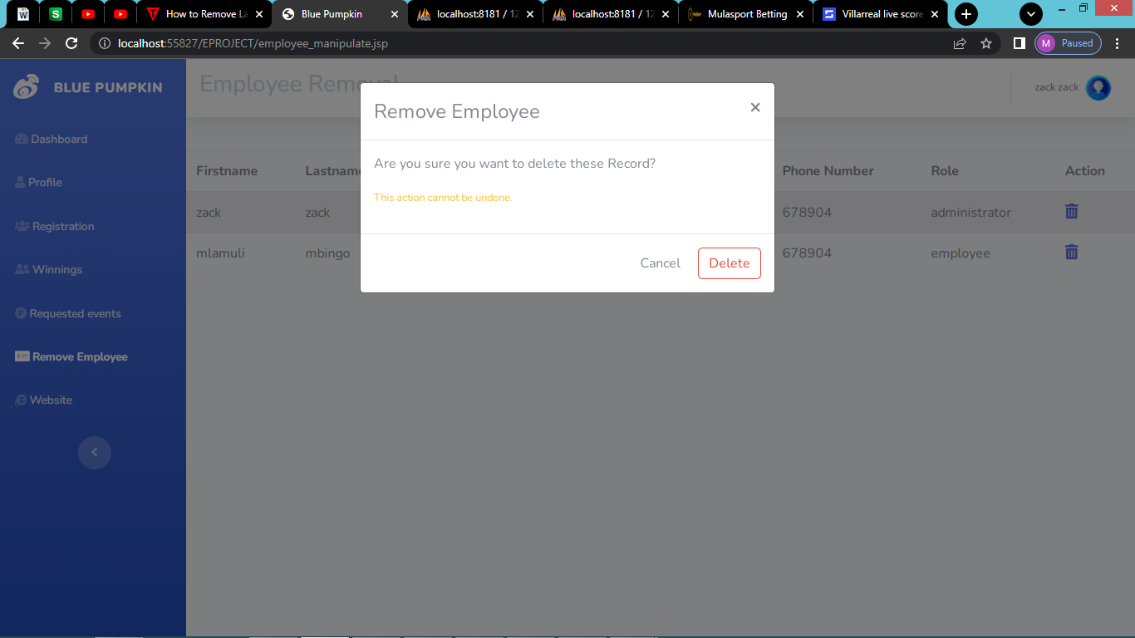

7.